**Hourly App Checker Run Book**

|  |  |
| --- | --- |
| Created By: | Sairam |
| Created On: | June 26th 2018 |
| Version: | V0.1 |

**Scheduling**

App checker will run with frequency of every one hour.

**User Communication**

User communication is not required.

**General Information**

Server: RHPBIPRG4.REYESHOLDINGS.COM

**App Check Purpose:**

Basically we will use the App Check data to find when the XRS RPT MBUS and MBCN data last updated.

**ISSUE#1 No failure but Hourly App Check data is not update to date**

We will get App Check data every one hour in mail with subject: HOURLY – BI APP CHECKER REPORT. Sample mail as follows.

[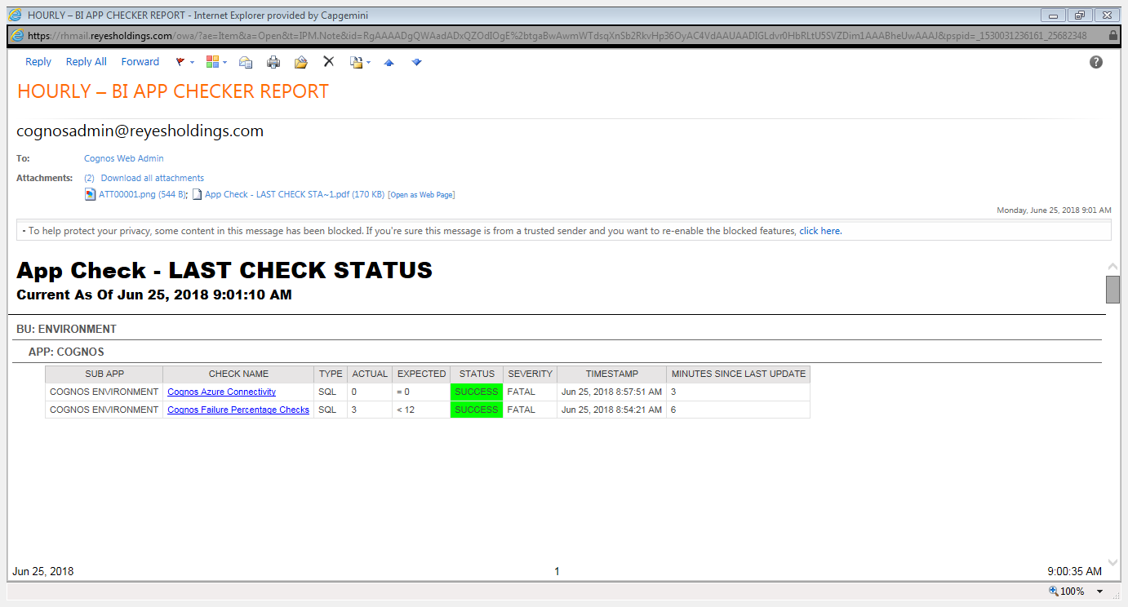](https://rhmail.reyesholdings.com/owa/?ae=item&a=open&t=ipm.note&id=rgaaaadgqwaadadxqzodioge%2btgabwawmwtdsqxnsb2rkvhp36oyac4vdaauaadigldvr0hbrltu5svzdim1aaabheuwaaaj&pspid=_1530031236161_25682348)

Note: Check the time stamp when this mail has been generated and time available in App Checker(Current As Of Jun 25, 2018 9:01:10 AM) pointed by arrow mark. Both the time stamp should match.

If time stamp is not matching as shown in below screen shot(time stamps are different) then restart the App Checker.

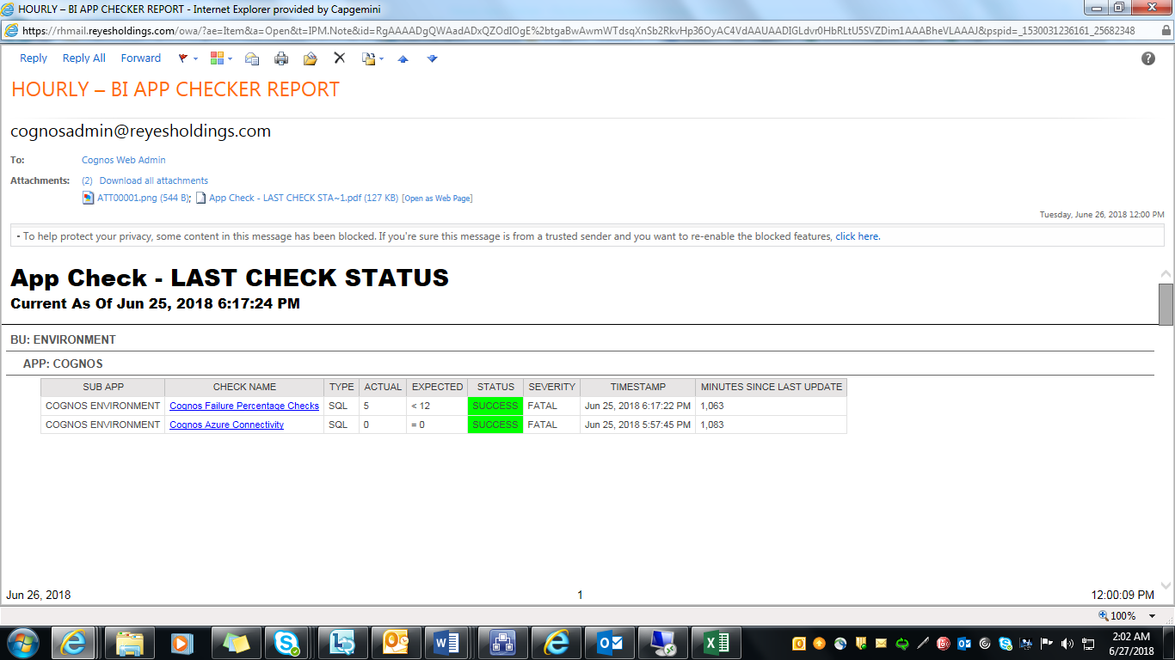

Steps to restart App Checker:

1.       RDP into RHPBIPRG4.reyesholdings.com as user $Cognos

2.       Verify the Checker.jar is not running  (Screenshot below shows it has stopped as you have the command prompt available)

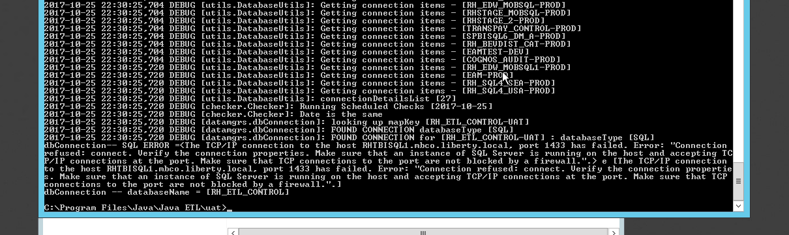

3.       Start the Checker.jar file  (see the command below)

